Phone: +49 211 881-4449
Fax: +49 211 881-774449
Mobile: +49 151 40226502
E-mail: thilo.sagermann@sms-group.com
Thilo Sagermann

PRESS RELEASE

Düsseldorf, October 19, 2016

Alcomet ready for expansion

Bulgarian manufacturer of aluminum products orders modern cold rolling mill from SMS group

Bulgarian aluminum product manufacturer Alcomet AD, located in Shumen, has awarded SMS group (www.sms-group.com) the order to supply a flexible, modern cold rolling mill for the production of a wide range of high-quality aluminum strips.

Alcomet is a leading supplier of rolled and extruded aluminum products in Eastern Europe thanks to the company’s 35 years of experience in non-ferrous metallurgy. The current portfolio of rolled products comprises foil stock for containers and household use, technological foils, sheet and strips for coolers, heat exchangers and for construction. The company uses in-house cast strip of alloy series 1xxx, 3xxx and 8xxx as input material.

The new cold rolling mill from SMS group, which will be of the proven CVCplus® six-high design, is an all-rounder. It will offer Alcomet the possibility to diversify the product range and enhance the product quality.

Top quality of the up to 2.2-meter-wide and 0.15-millimeter-thin strip will be ensured by the tried and tested interaction between CVC® and a comprehensive range of further actuators, all of which are coordinated by the SMS group’s automation and control system AluControl®.

A Multi-Plate® filter, one of the SMS group’s ecoplants modules, will provide for ecological and economical treatment of the rolling oil.

SMS group will manufacture all mechanical key components in their workshops in Germany, ensuring highest equipment quality over a long service life.

A convincing plant concept, proven technology as well as comprehensive experience in building high-quality aluminum rolling mills were the decisive factors for awarding SMS group this supply order.

“Our project had started out with the plan to revamp an existing cold rolling mill and evolved into building a new rolling mill of the latest design, which allows us to meet our customers’ future demands. Throughout this process, the SMS team supported us as partners with great enthusiasm, professionalism and flexibility.“ Huseyin Yorucu, Alcomet AD, Chairman of the Management Board
(38 lines of max. 65 characters per line)

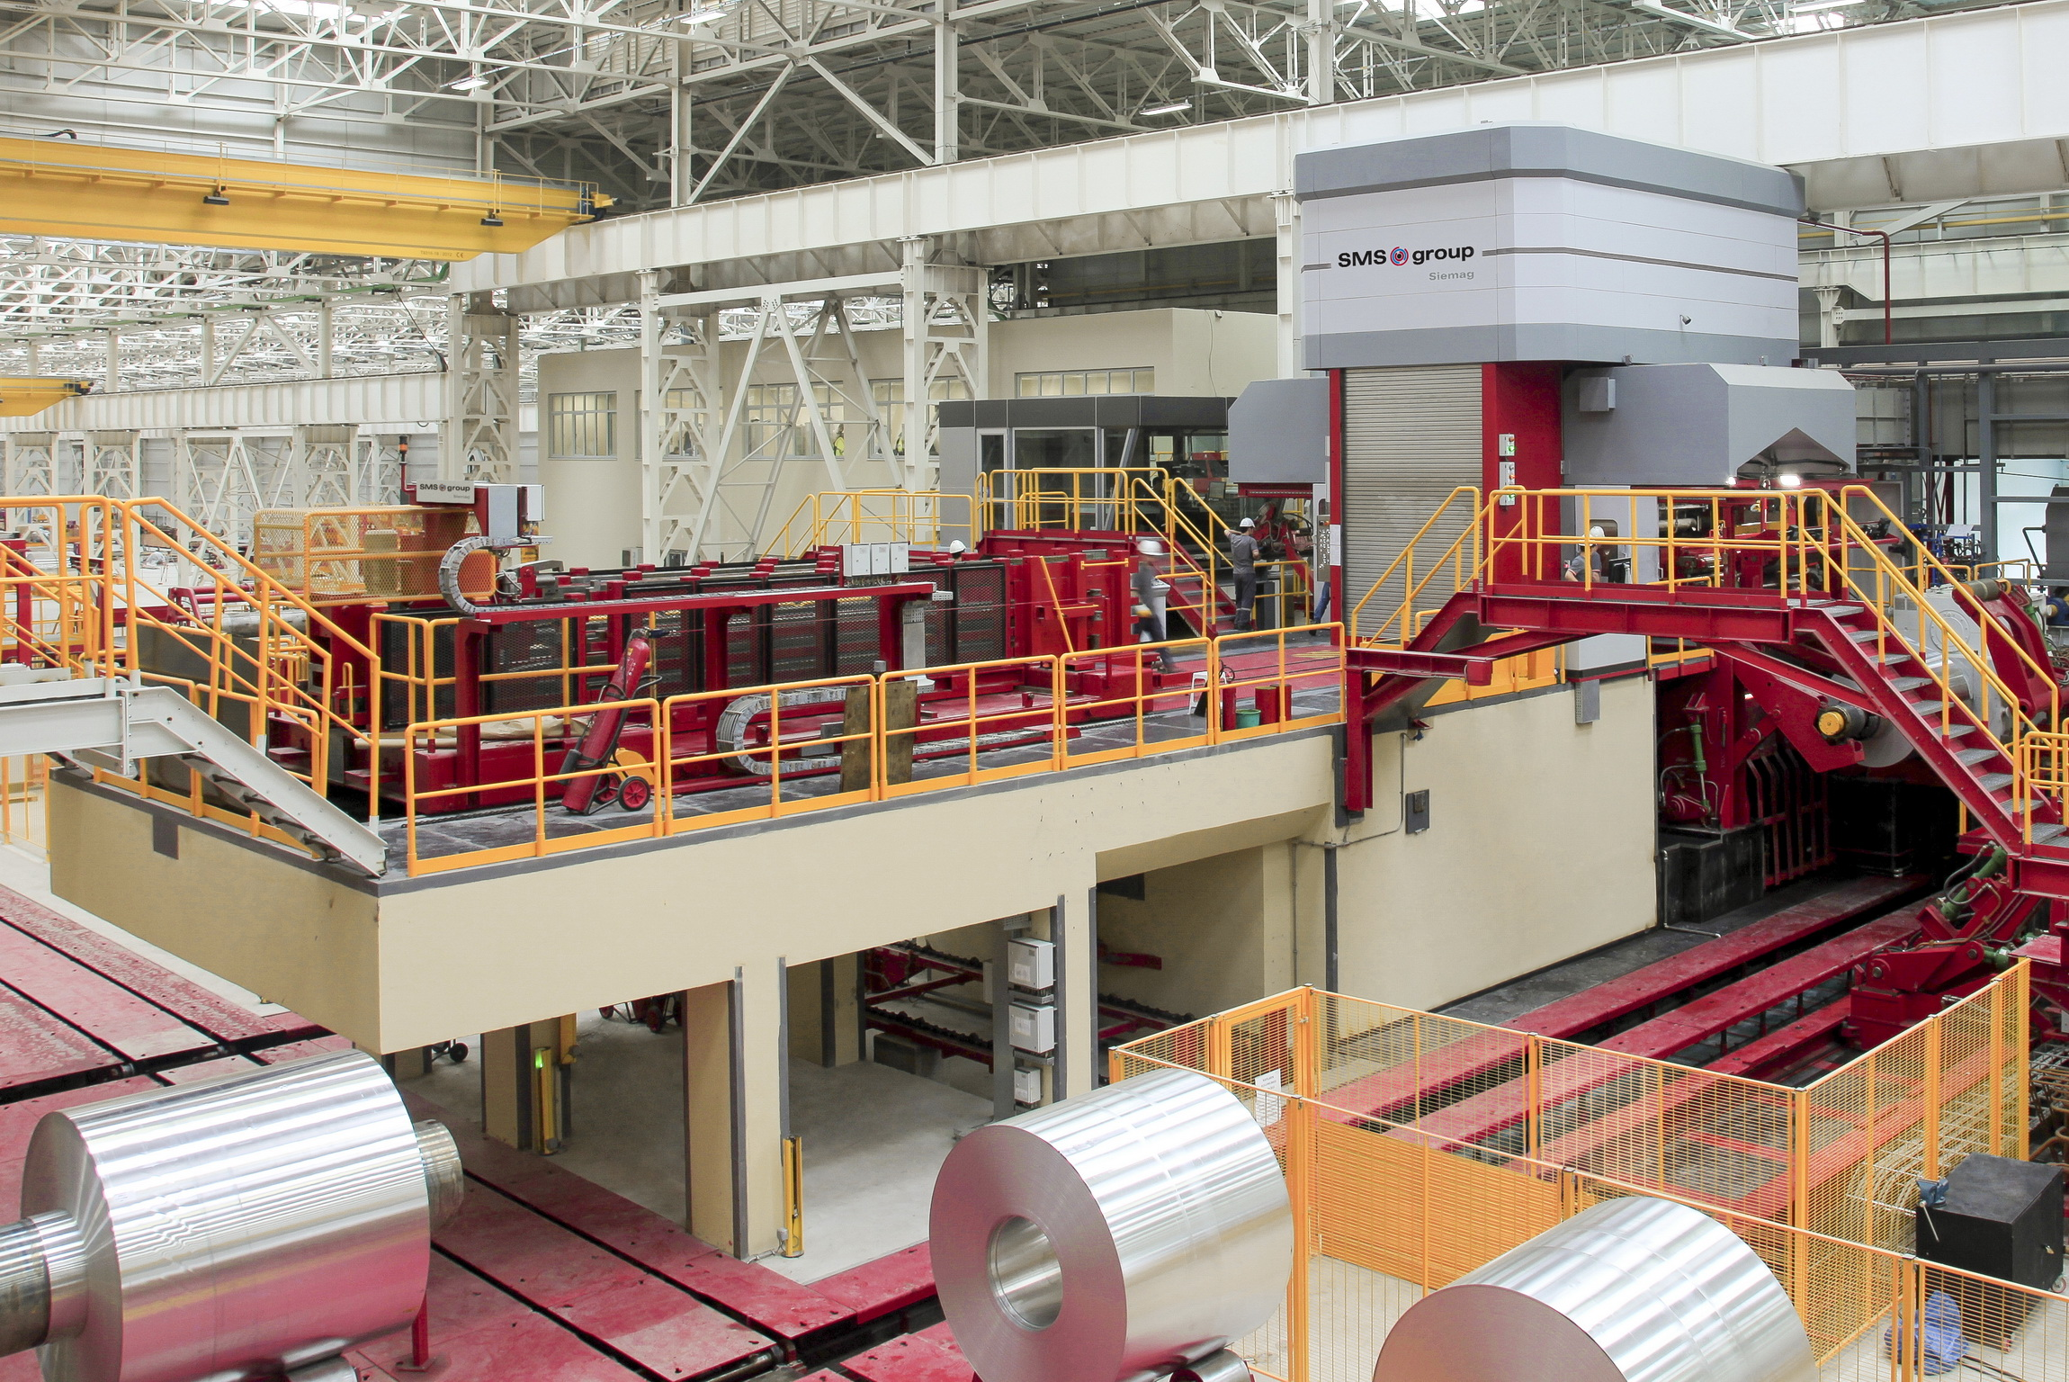
Aluminum cold rolling mill built by SMS group.

