Phone: +49 211 881-4449
Fax: +49 211 881-774449
Mobile: +49 151 40226502
E-mail: thilo.sagermann@sms-group.com
Thilo Sagermann

PRESS RELEASE

Düsseldorf, December 12, 2016

Lower energy consumption, higher filter performance

Uddeholm AB Hagfors successfully modernizes exhaust gas purification system of electric arc furnace with latest technology from SMS group

Sweden-based Uddeholm AB Hagfors, manufacturer of tool steel for industrial tools, has successfully commissioned phase one of the modernization of the EAF fume treatment plant with latest filter technology from SMS group (www.sms-group.com). As phase one of the project, SMS group upgraded the roof canopy installing a high-efficiency EAF fume evacuation hood – the patented SMS Frustum –, replaced the existing secondary duct system, installed a highly efficient axial cyclone and a new pulse jet filter.

The newly developed high-performance equipment from SMS group ensures a higher suction capacity of 800,000 cubic meters per hours with a ten filter compartment. The two fans with 710 kW variable speed motors reduce energy consumption thanks to the “Total Pressure 11” concept (280 mmWG). Additionally, the noise level recorded at a selected point on the property line was below 45 dBA at night and the dust content at the stack discharge was more than 50 percent lower than required. The new filter technology from SMS group thus helps Uddeholm to achieve better evacuation of the exhaust gases during the melting process in the electric arc furnace, while minimizing energy consumption.
Due to the improved suction efficiency of the existing canopy hood thanks to the “frustumized” design, the old filter, which had been planned to remain in operation, was switched off. This provided additional energy benefits.

With the substitution of the primary fume line, the second phase, planned for August 2017, will complete the EAF fume treatment plant modernization.

The first project phase was executed on a turnkey basis during a period of twelve months. The extremely high safety standards resulted in zero injuries and accidents.

The approach of lean engineering adopted in this modernization project provided for a tight execution and construction schedule. However, the experienced team of SMS group in Italy executed the project without delay. Such an approach is a decisive factor in the successful implementation of such projects as it provides balanced investment costs, a secure execution time and high-quality service.

(39 lines of max. 65 characters per line)

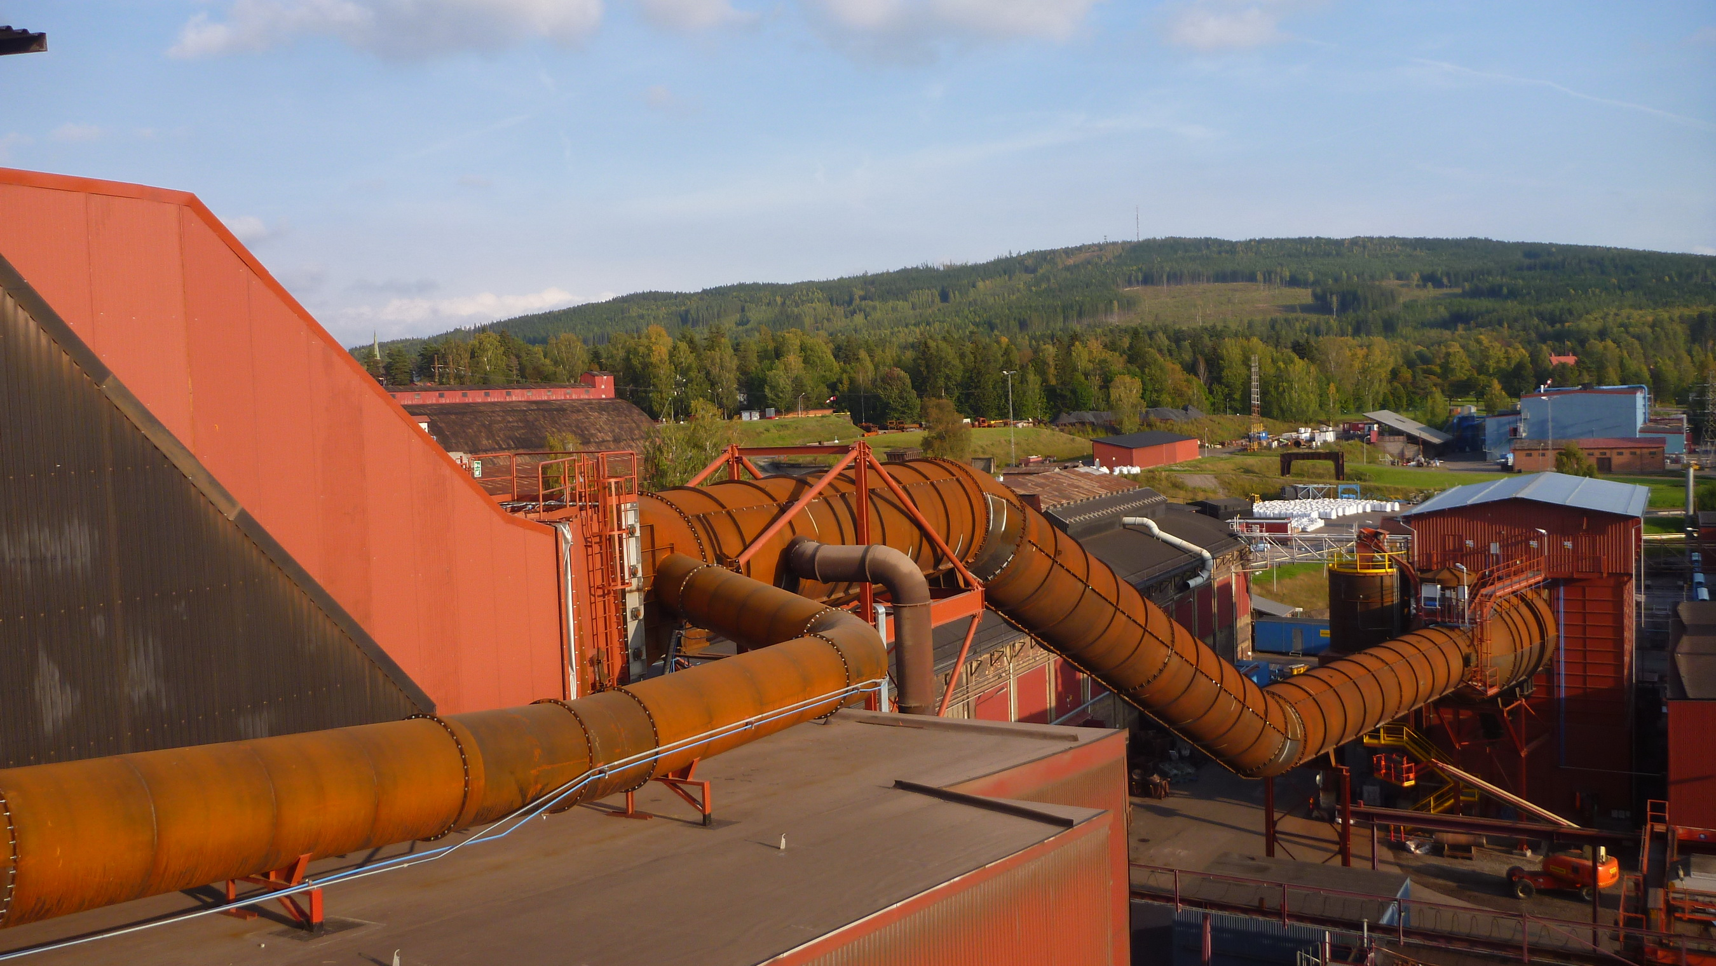
New secondary and inlet duct to the filter unit supplied by SMS group.

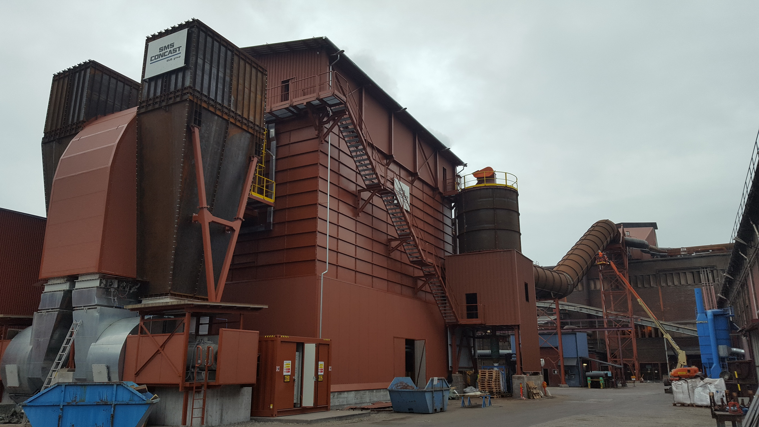
Fan configuration and stack design with reduced chimney dimension. The high-performance filter from SMS group requires less energy.

