Phone: +49 211 881-4449
Fax: +49 211 881-774449
Mobile: +49 151 40226502
E-mail: thilo.sagermann@sms-group.com
Thilo Sagermann

PRESS RELEASE

Düsseldorf, January 31, 2017

High productivity and product quality due to energy savings of up to 25 percent

apt Hiller places order with SMS group for 27-MN front-loading press

apt Hiller GmbH headquartered in Monheim, Germany, has meanwhile ordered already the fourth front-loading extrusion press from SMS group (www.sms-group.com).

The new extrusion press operates with an extrusion force of 27 MN (2,700 tons) in front-loading design, thus enabling high productivity and product quality. At the Monheim location, it replaces an older 20/22-MN extrusion press of apt Hiller GmbH. At the same time, a new highly effective billet heating furnace will be installed and part of the runout equipment will be newly built.

Moreover, the new press is equipped with an “ecoDraulic“ system, an intelligent automatic start-stop system which is able to deactivate unused pumps. By installing a particularly fast hydraulic system shortest idle times can be achieved. Compared to conventional presses, the employment of these energy-efficient components and systems enables energy savings of 25 percent. Hence, the new press at apt Hiller meets the criteria of the distinctive ecoplants mark for especially energy efficient machines of SMS group.
“apt Group stands for reliable top quality. In accordance with our slogan “Essential Parts - Essential Partners“, we are pleased to have SMS group as such a reliable partner at our side and we are sure that the forth front-loading press will also satisfy our expectations as regards quality and reliability,“ said Thomas Boddenberg, Managing Director apt Hiller GmbH.

On the 27-MN extrusion press line, apt will be producing high-end aluminum profiles primarily applied in the construction and construction product sectors.

The new line will go into operation in the first quarter of 2018.

(32 lines of max. 65 characters per line)

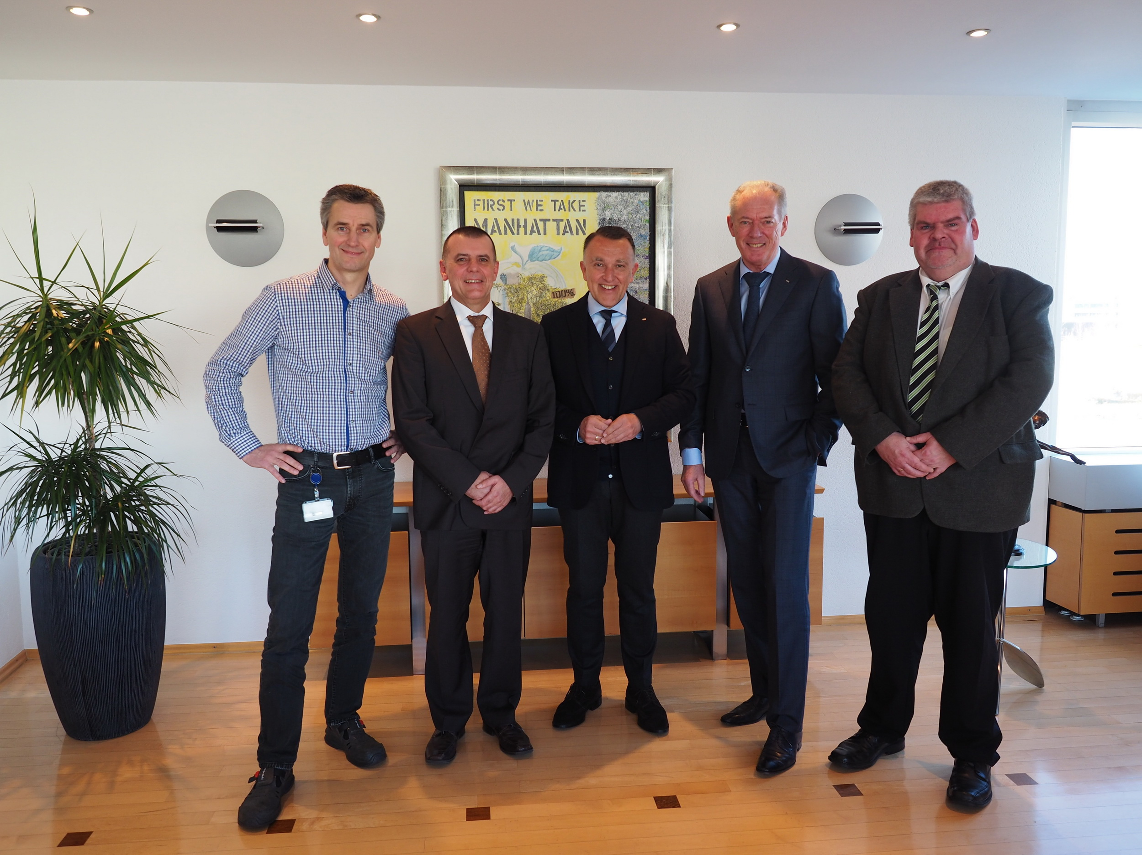
From left to right: Thomas Brockmann (Head of Technology apt Hiller GmbH),
Hans-Uwe Rode (SMS group), Thomas Boddenberg (Managing Director apt Hiller GmbH), Frans Kurvers (Managing Partner apt Group), Toni Herrmann (SMS group).

